**Linux Task Day-1:-**

1. **Create a linux user and set a password for the user.**
2. **Switch the user and create a directory including its sub directory under the newly created user’s home directory.**
3. **Create file using cat and echo command.**
4. **Change the executable file permission for the file.**
5. **Change the owner of the file.**

**1. Create a linux user and set a password for the user.**

* Create the user with the **adduser** or **useradd** command and the **-m** option to create a home directory.
* Set the password for the user with the **passwd** command.

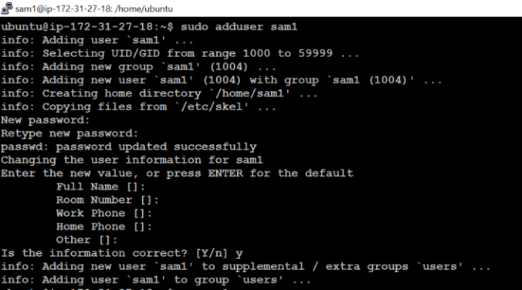

**2. Switch the user and create a directory including its sub directory under the newly created user’s home directory.**

* The **su** command allows you to switch to another user account.

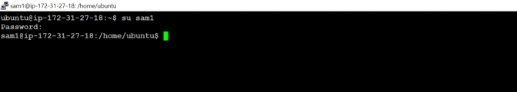

* create a directory and subdirectory under the new user's home directory. Use the **-p** option with **mkdir** to create the full path, including any intermediate directories that do not exist.

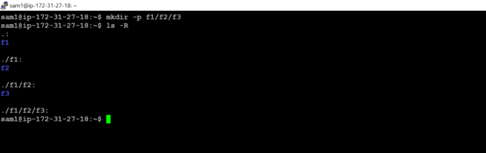

**3. Create file using cat and echo command**

* The cat command is commonly used to display file contents, but it can also be used to create files and input text interactively.

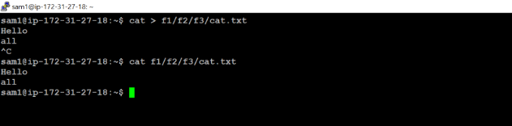

* The echo command outputs the text you provide to the terminal, but it can also be used to write text to files.

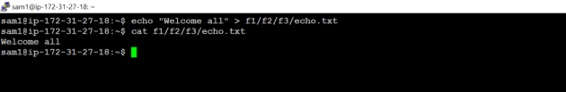

**4. Change the executable file permission for the file**

* The **chmod** command allows you to modify the permissions of a file. To make a file executable, you need to add execute permissions. You can do this using symbolic mode or numeric mode.

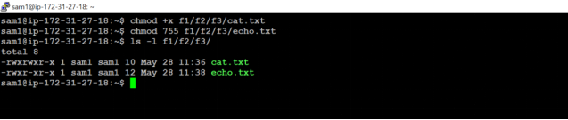

**5. Change the owner of the file**

* The **chown** (change owner) command allows you to specify a new owner for the file.

**Error:**

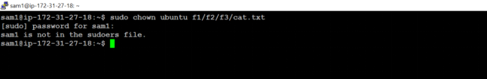

**Solution:**

* Switch to a User with **sudo** Privileges
* Edit the **sudoers** File

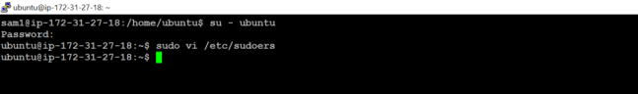

* Add sam1 to the **sudoers** File
* Save and Exit

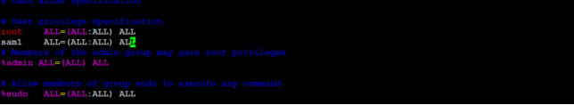

* Now we can see the file owner changed from **sam1** to **ubuntu** for cat.txt

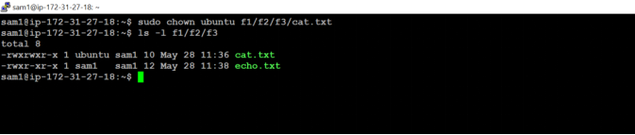

**Linux Task Day-2:-**

1. **Create two servers in aws and make sure both servers are pinged.**
2. **Create a file in server A and copy that file into Server B.**
3. **Create a shared directory in server A and Create a file under shared directory in server B and that should be reflected in server A under the shared directory.**
4. **Create two servers in aws and make sure both servers are pinged.**

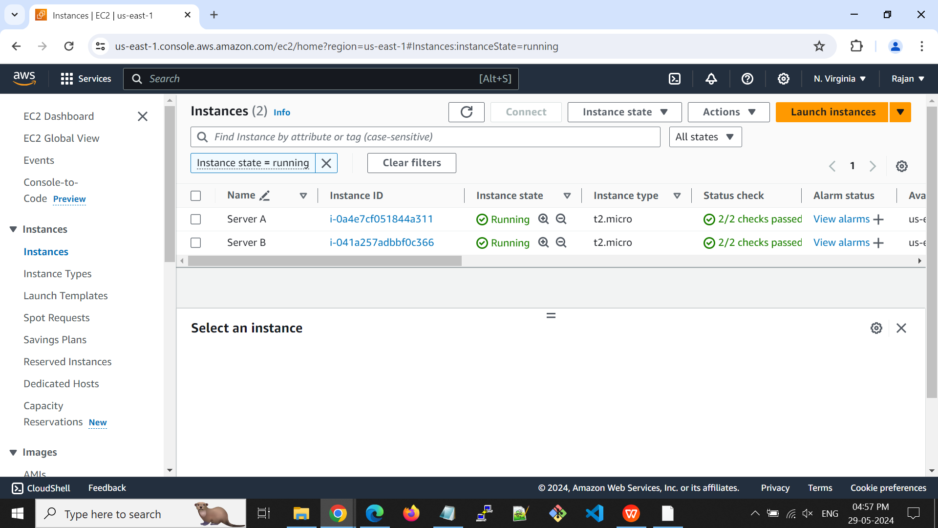

* Before pinging of two servers, need to ensure that ICMP port allowed or not

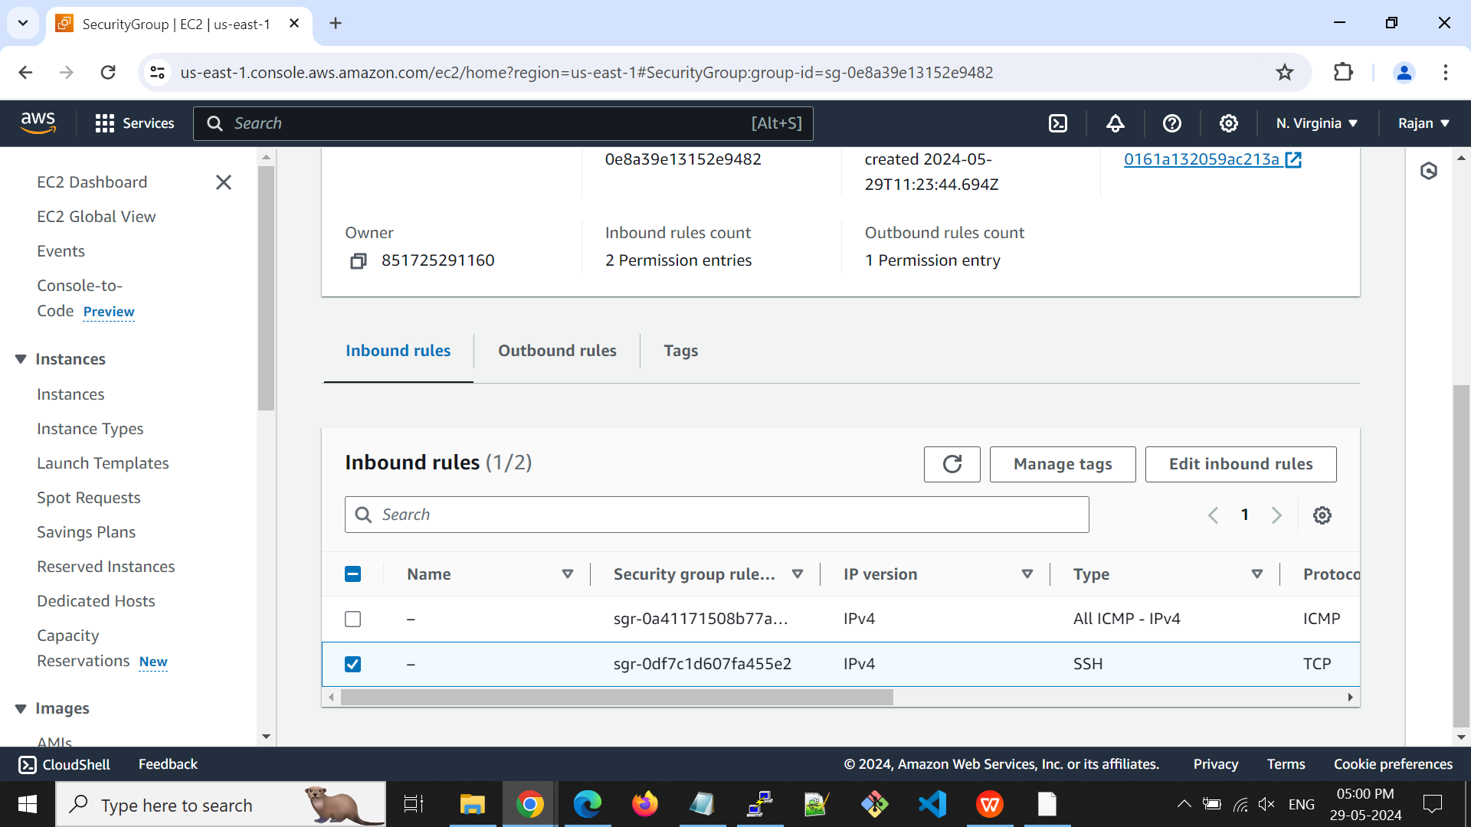

* Now, ping both servers using the ping command.

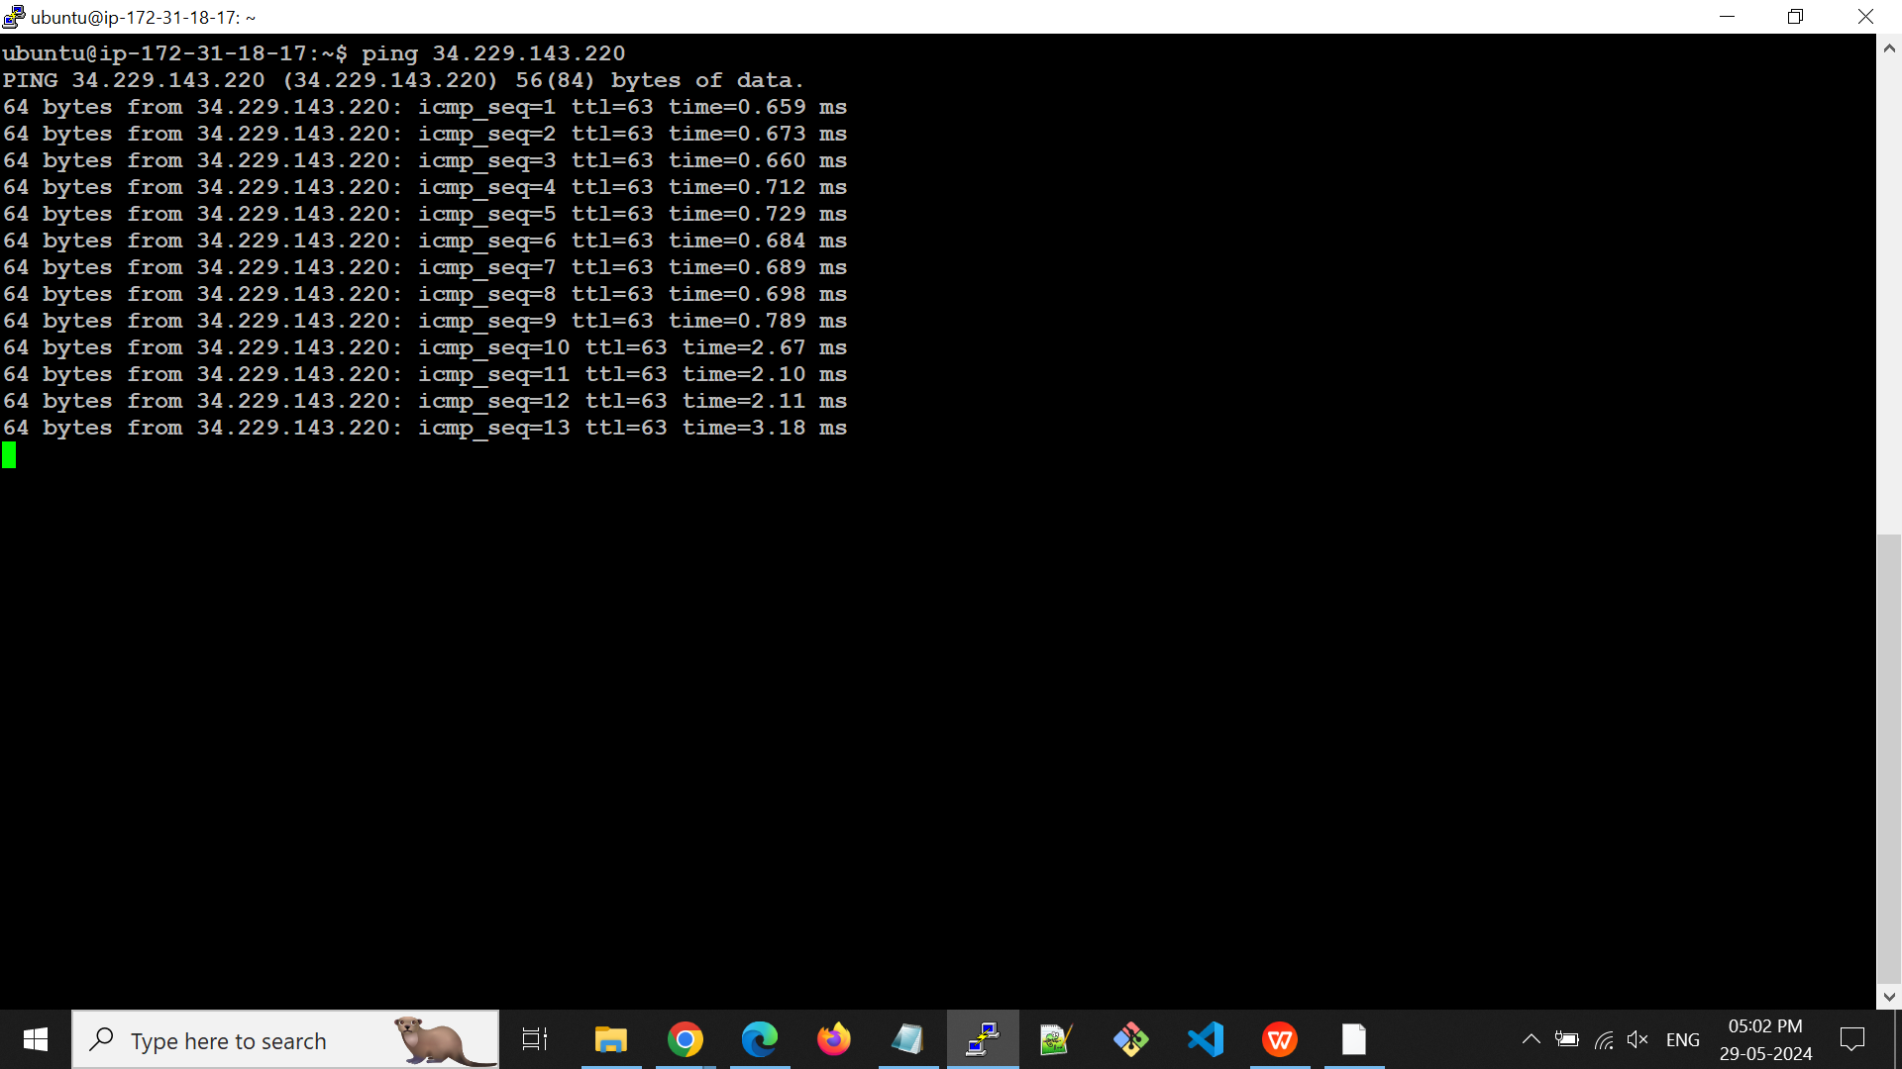

1. **Create a file in server A and copy that file into Server B.**

* File created in server A.

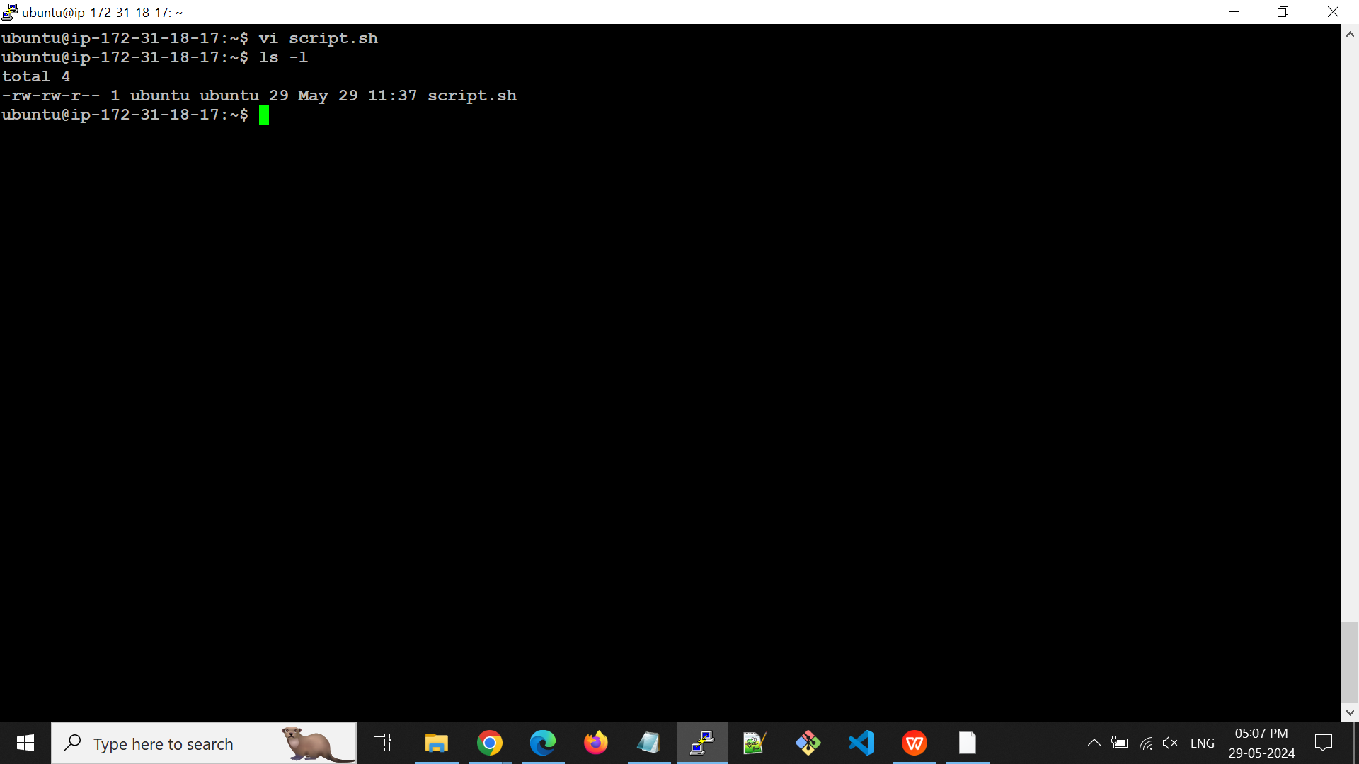

* Before that I need to set up an ssh connection for both servers.

**Step 1**: On each server run **ssh-keygen**

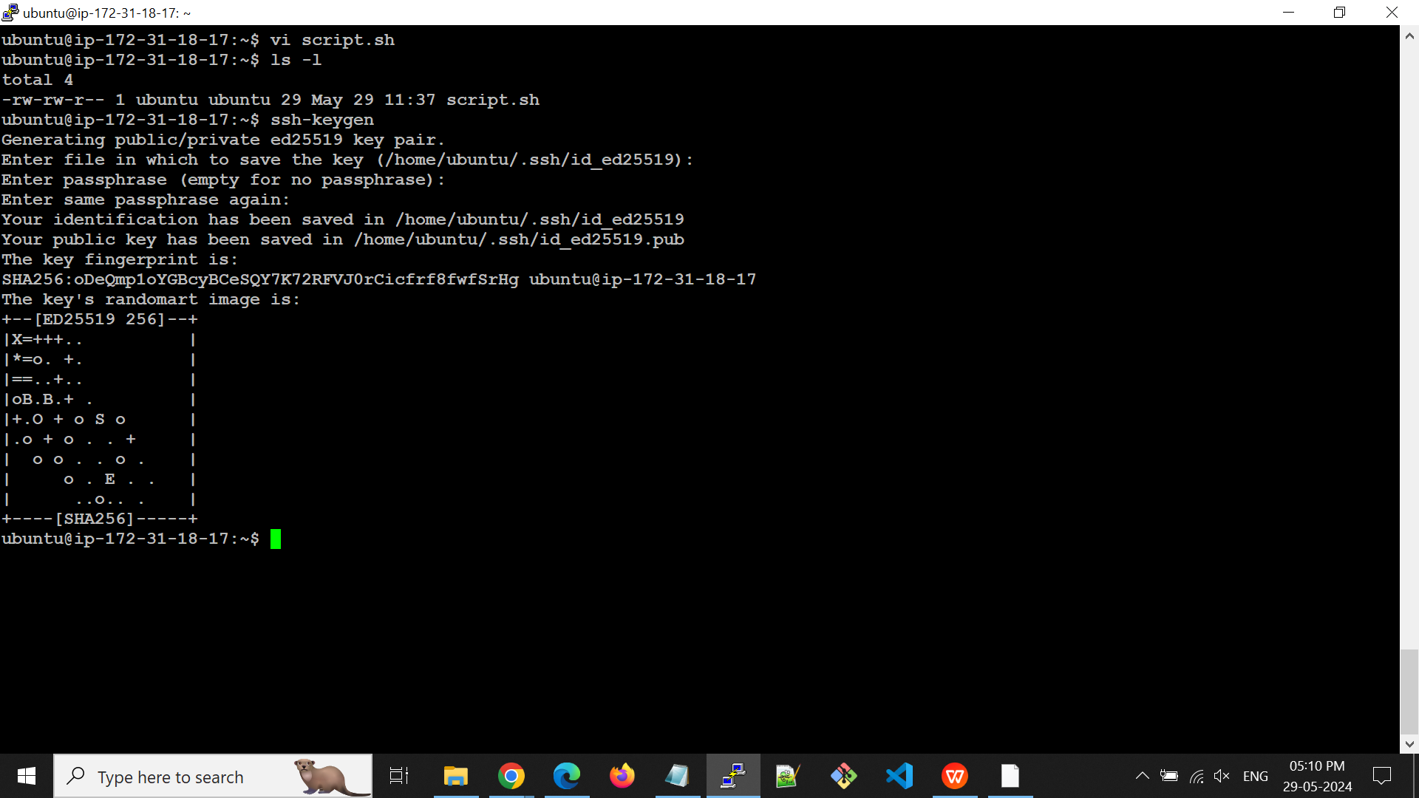

**Step 2**: Created two files under **/home/ubuntu/.ssh**

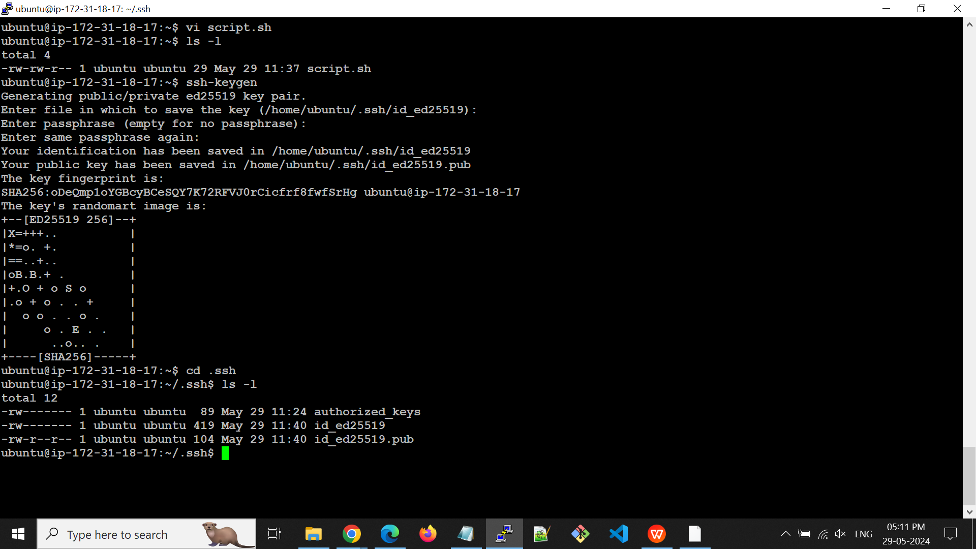

**Step 3**: On Server A, cat and copy the public key

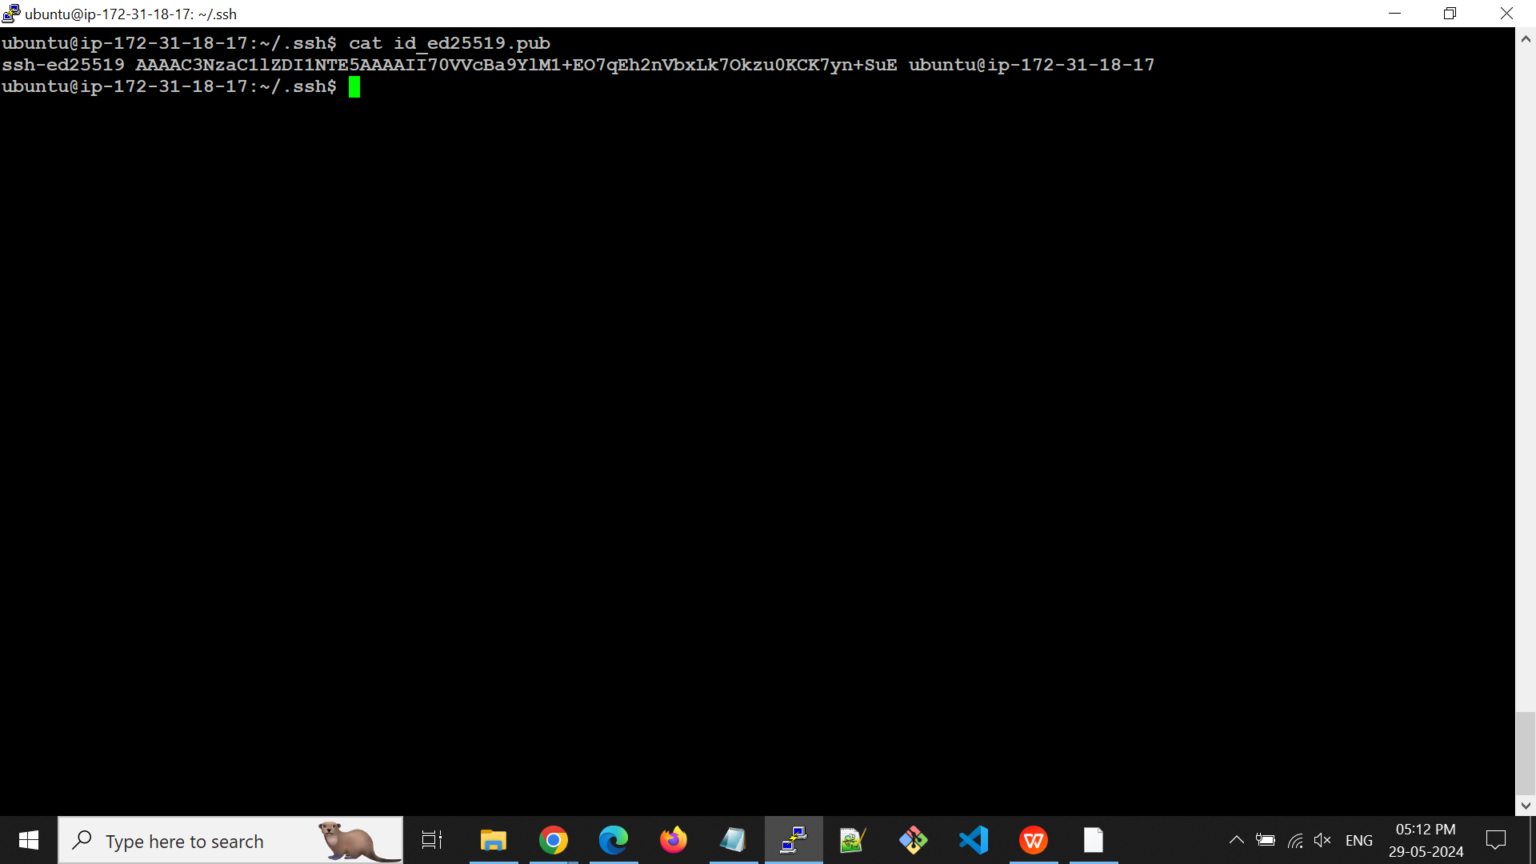

**Step 4**: select and copy to the key and append the key into /home/ubuntu/.ssh/authorized_keys file of Server B.

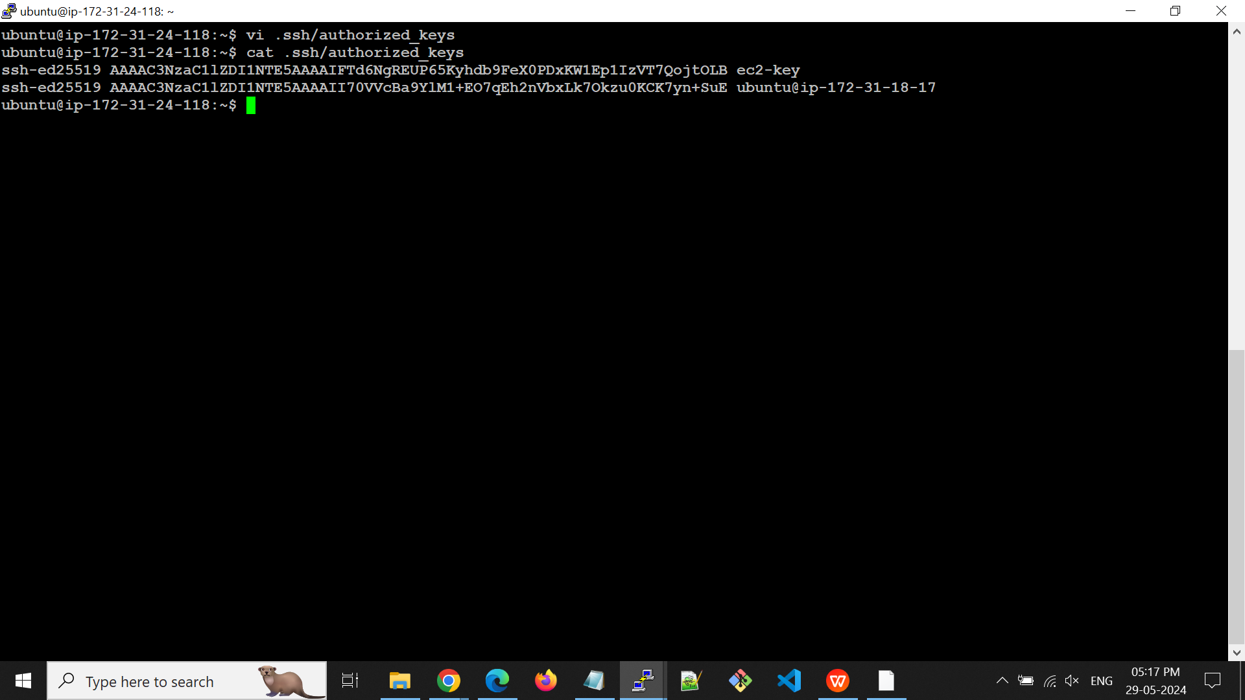

**Step 5:** Now ssh from server A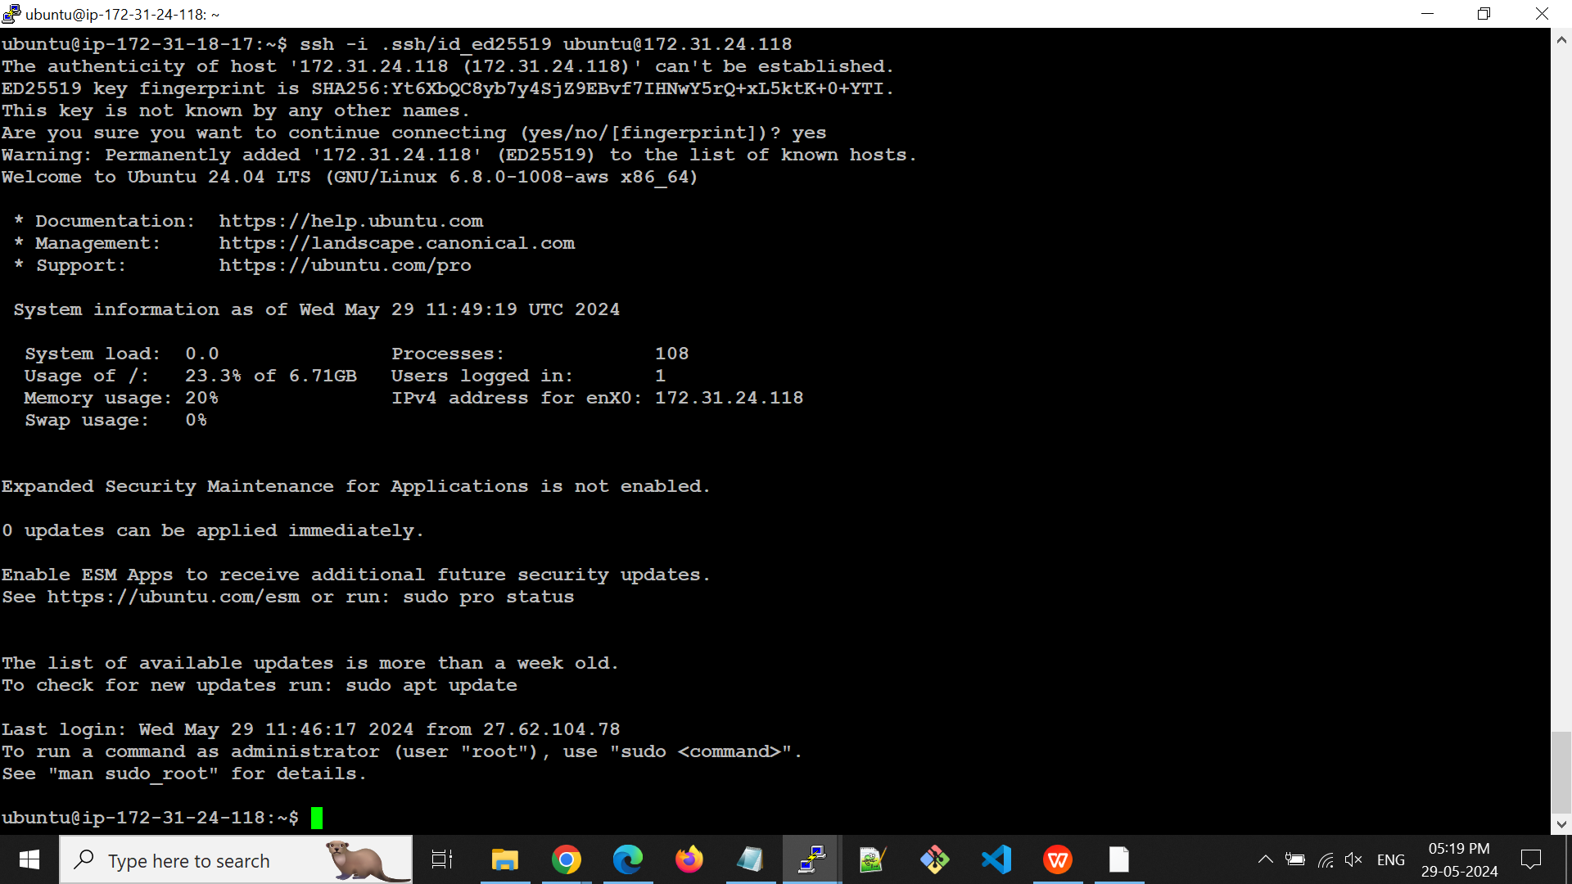

* Now paste the copied file from Server A into Server B using secure copy command.

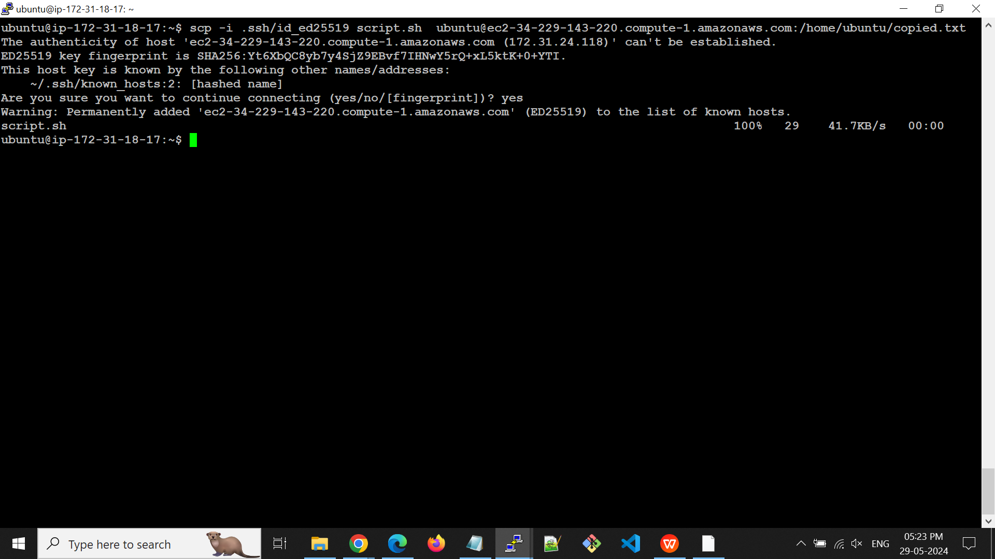

* Now do ls -l in Server B we can see the cooped file from Server A.

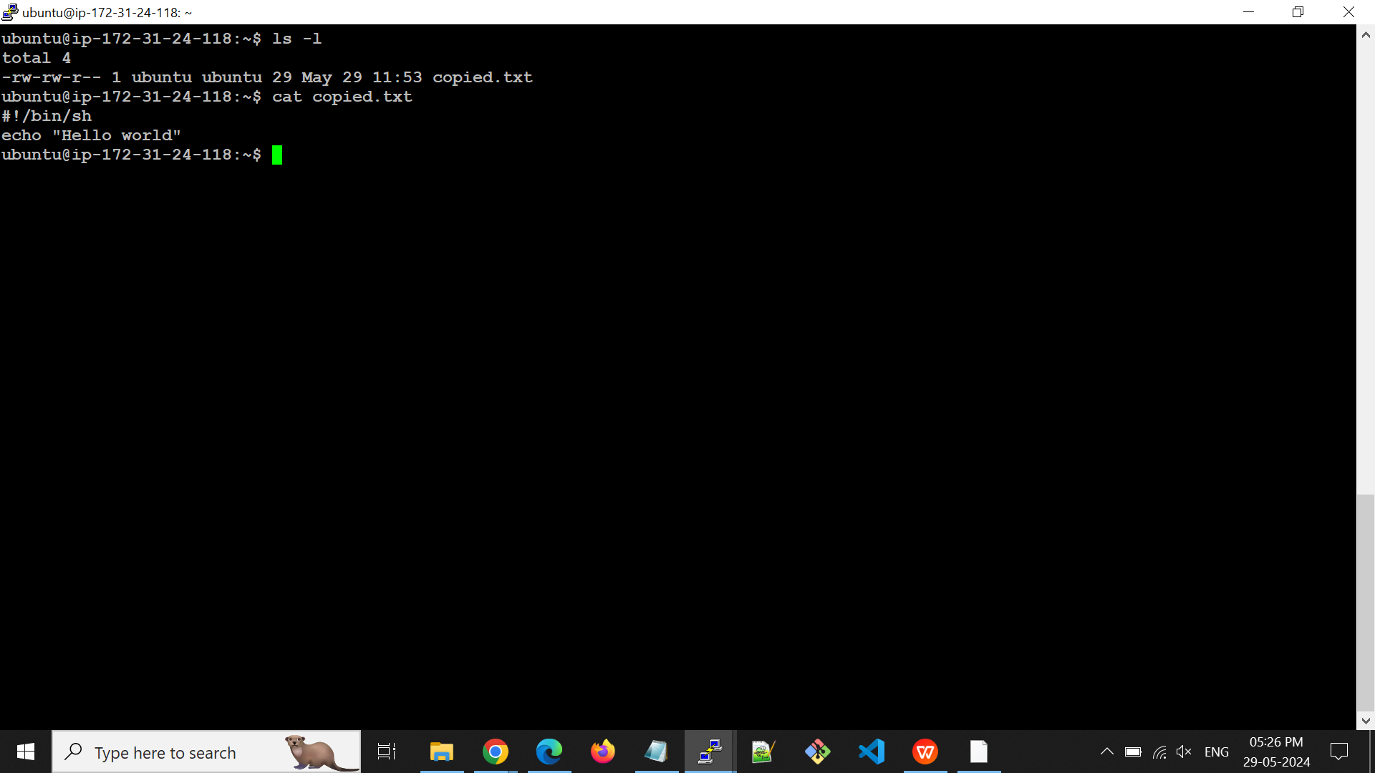

1. **Create a shared directory in server A and Create a file under shared directory in server B and that should be reflected in server A under the shared directory.**

* Install NFS Server Software on Server A

sudo apt update && sudo apt install -y nfs-kernel-server

* Create a directory in Server A under **/mnt** that will serve as the shared directory.

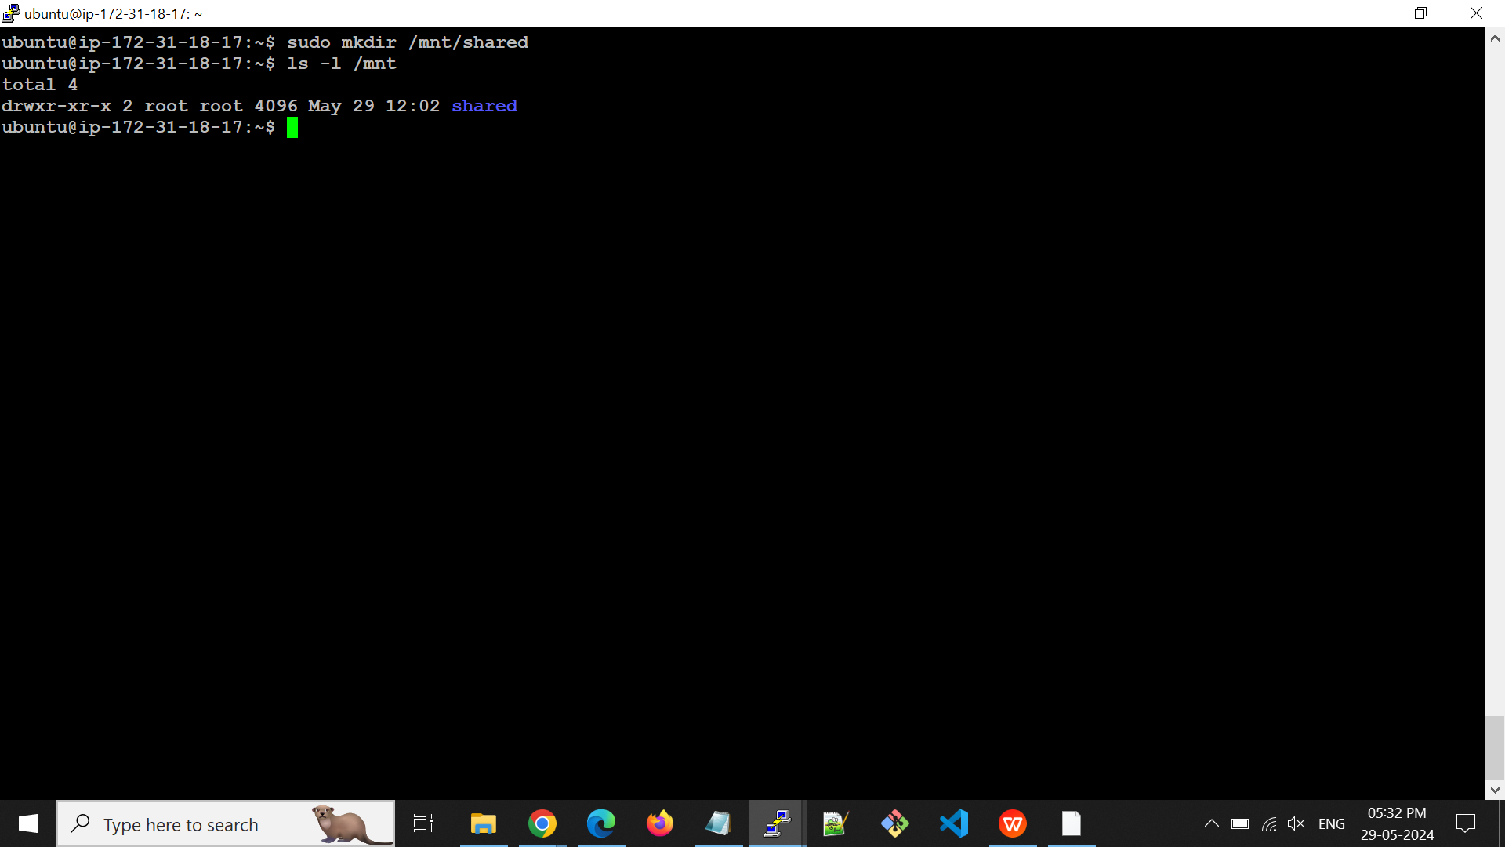

* Adjust the permissions of the shared directory to allow access to the users or groups that need it.

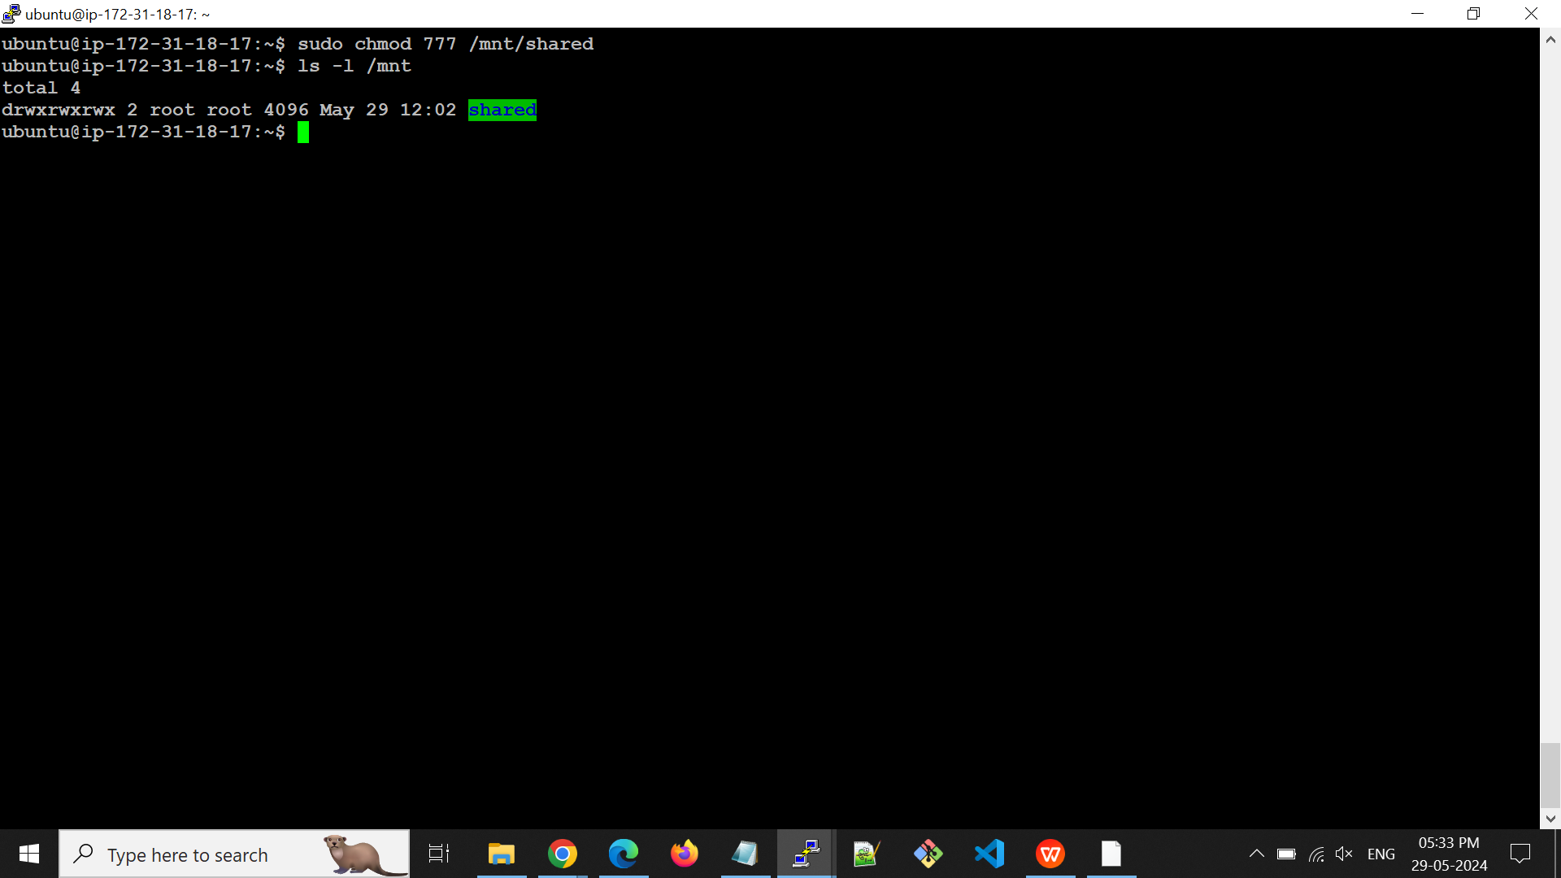

* Edit **/etc/exports** to Configure NFS Exports.This file contains the configuration for which directories are shared and with which clients they are shared.

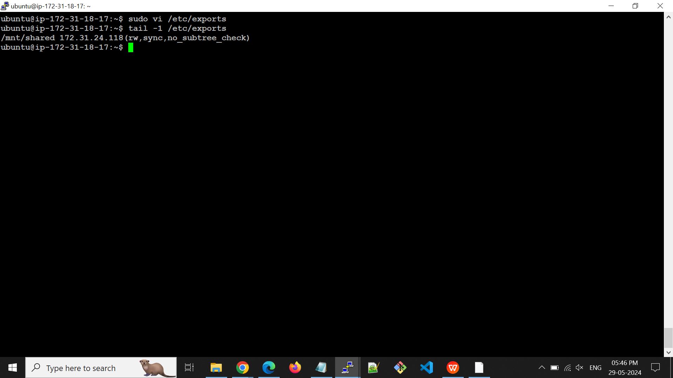

* Export the shared directory using this command.

sudo /etc/exportfs -a

* Restart the NFS service

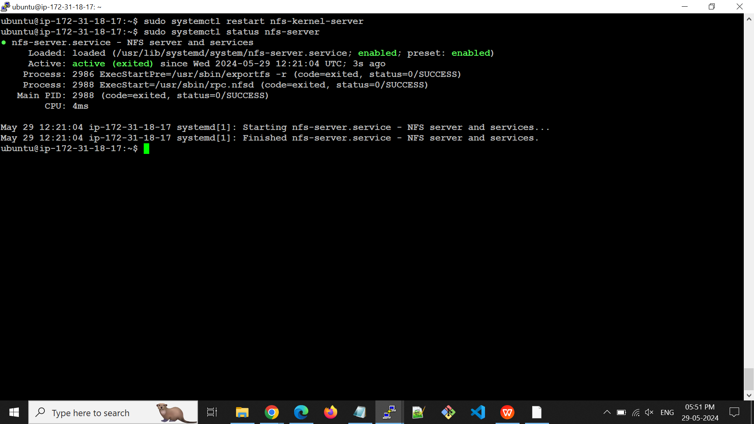

* Install NFS client in Server B using this command

sudo apt update && sudo apt install -y nfs-common

* Create a directory in Server B under **/mnt** for mount to Server A shared directory.

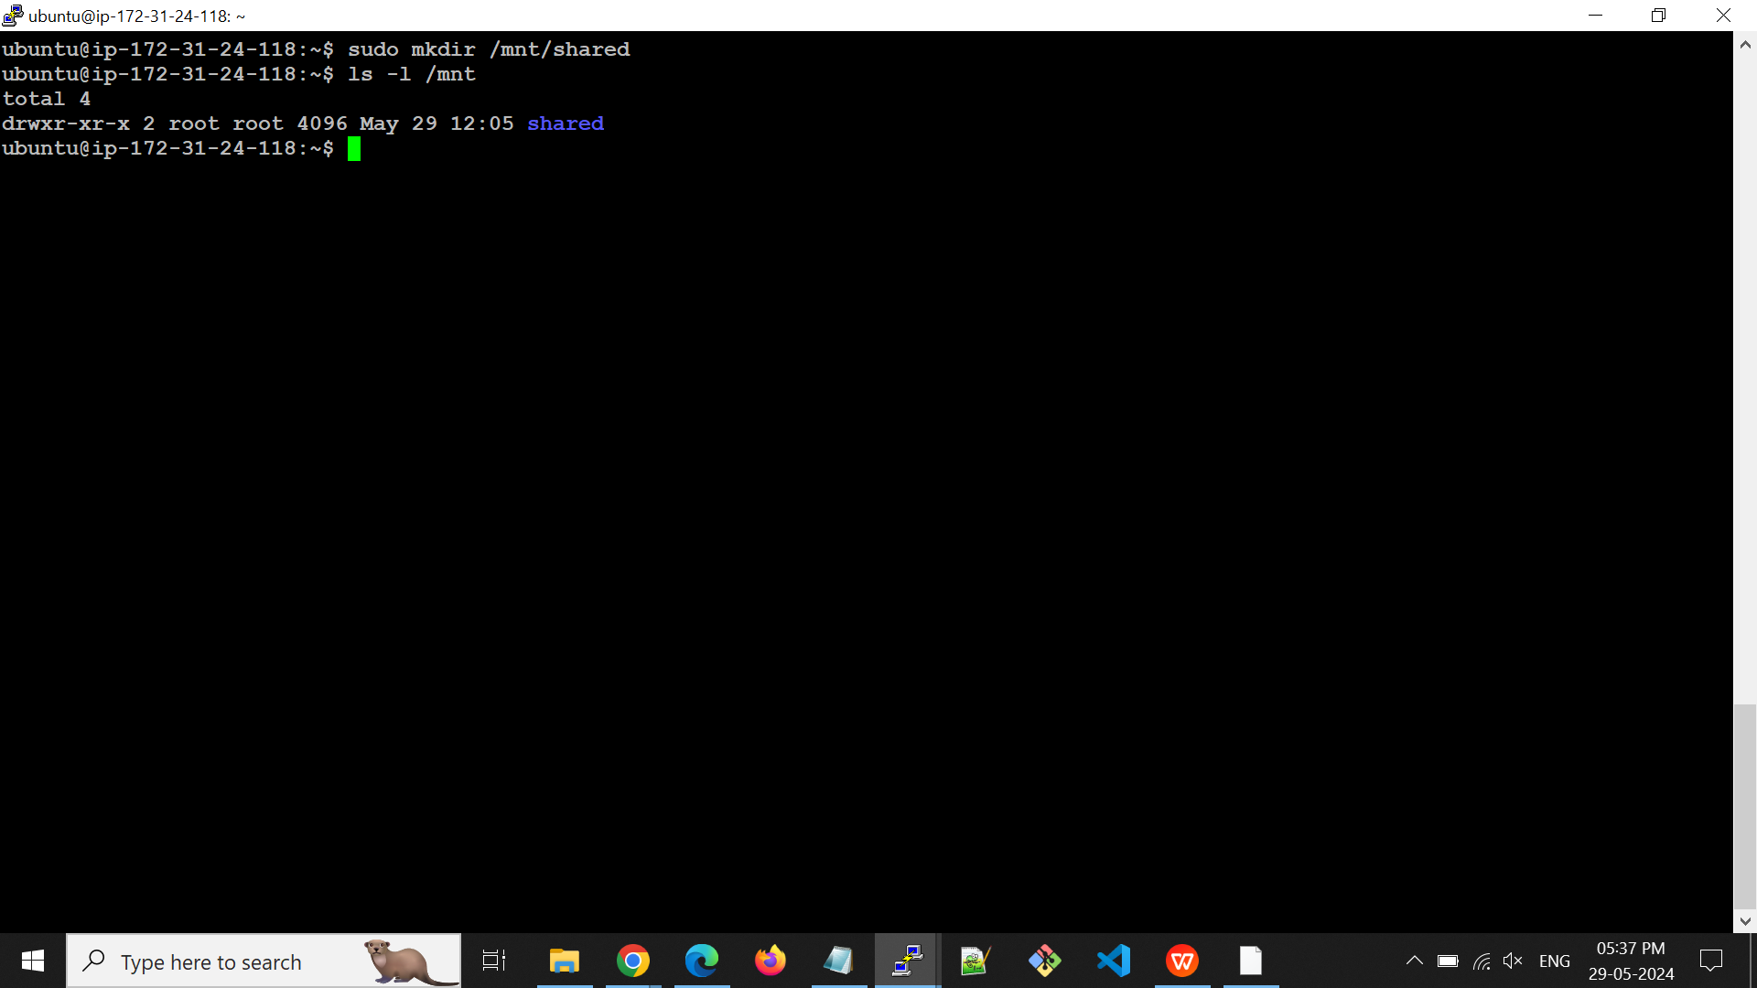

* Ensure that NFS ports are allowed in the security group. If now allowed, add the rule for NFS ports.

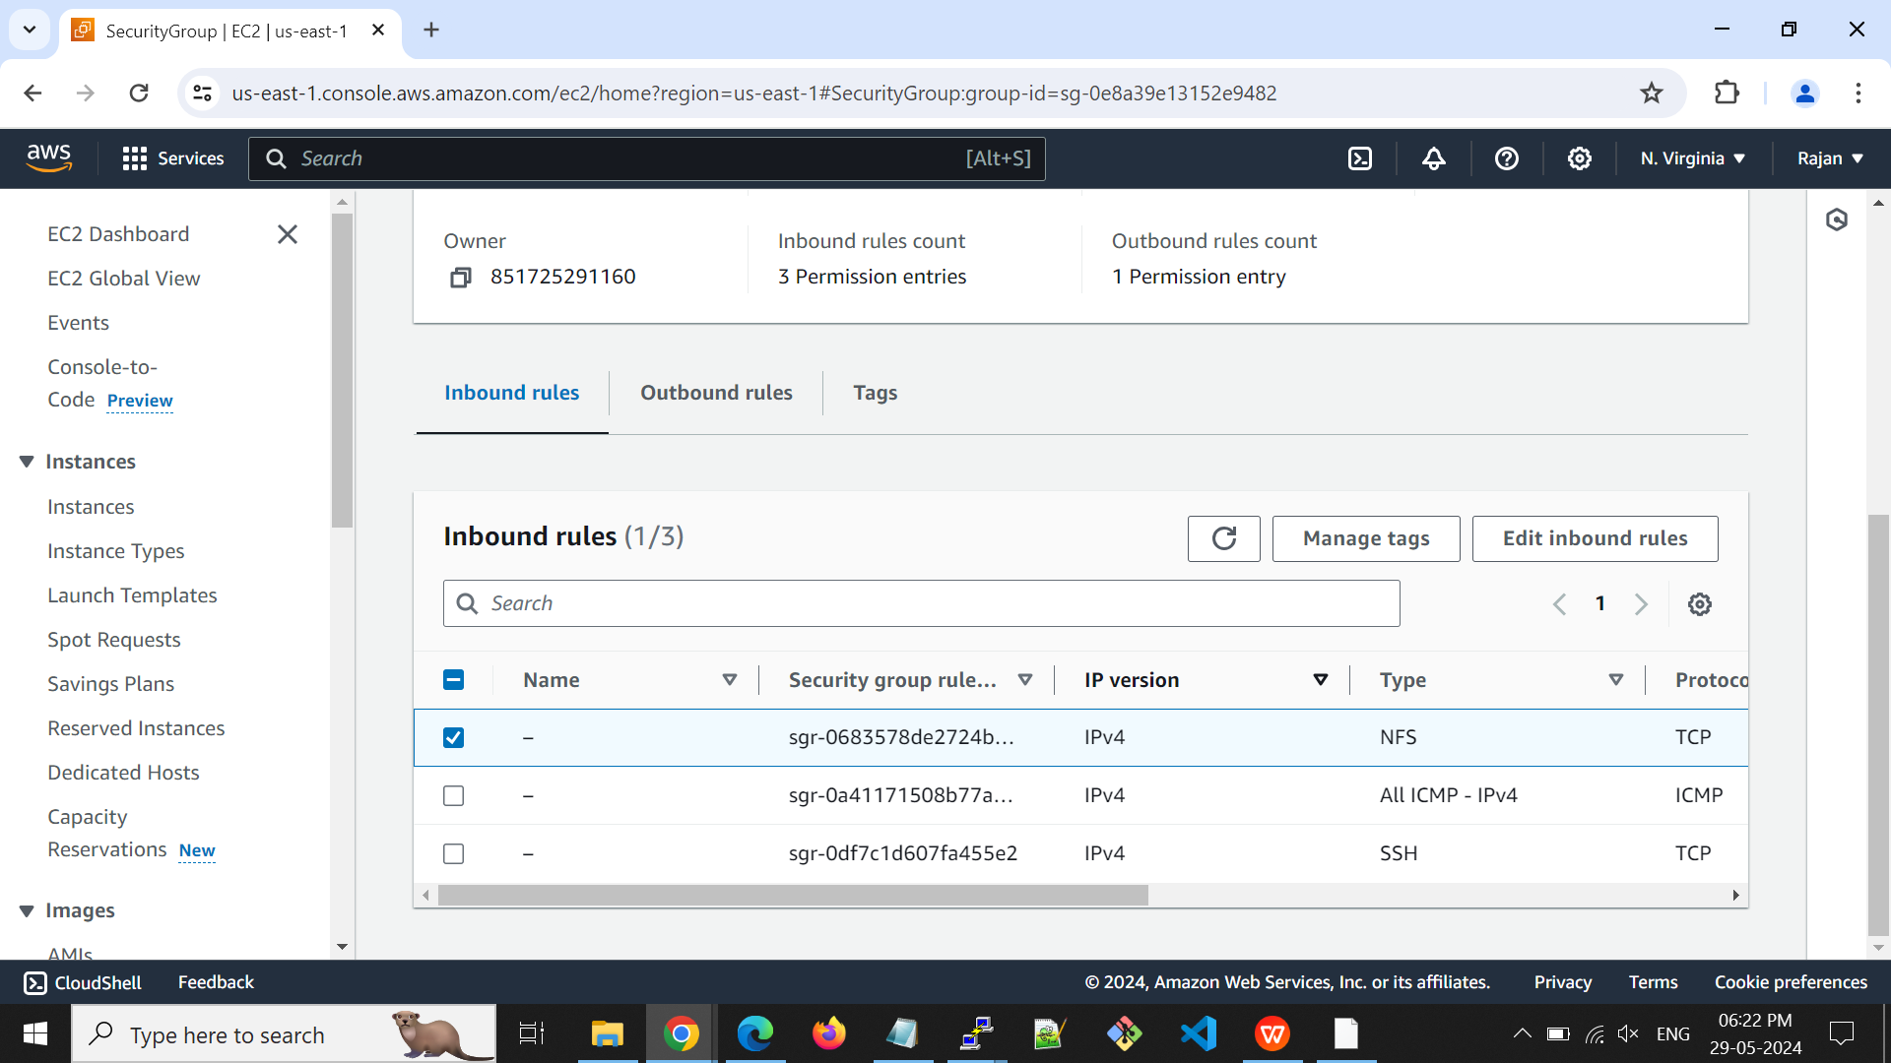

* Now, mount the Server A and Server B directories. Created file under /mnt/shared/serverB-file.

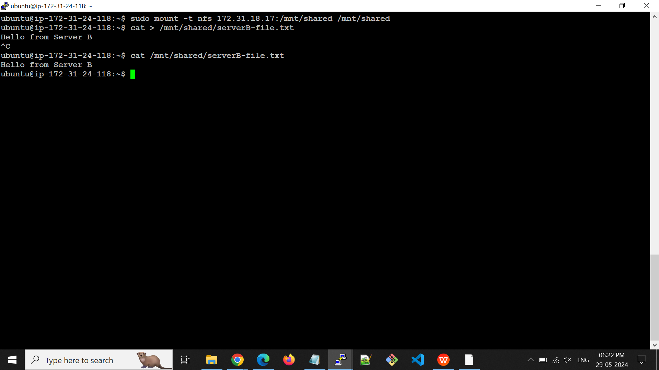

* Now we can see the Server B file in Server A.

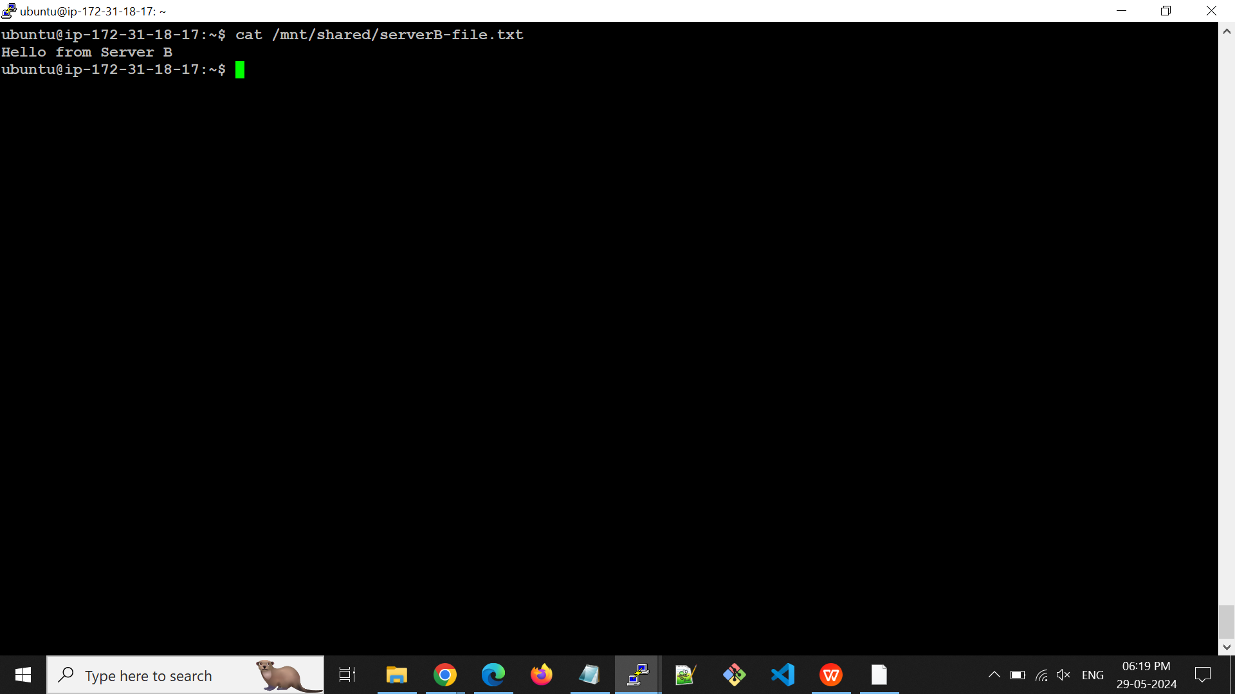

**AWS Task Day 3:-**

**Provide the internet to private EC2 instances using NAT instances.**

**Step 1:** Created a VPC with CIDR block range 10.81.0.0/16.

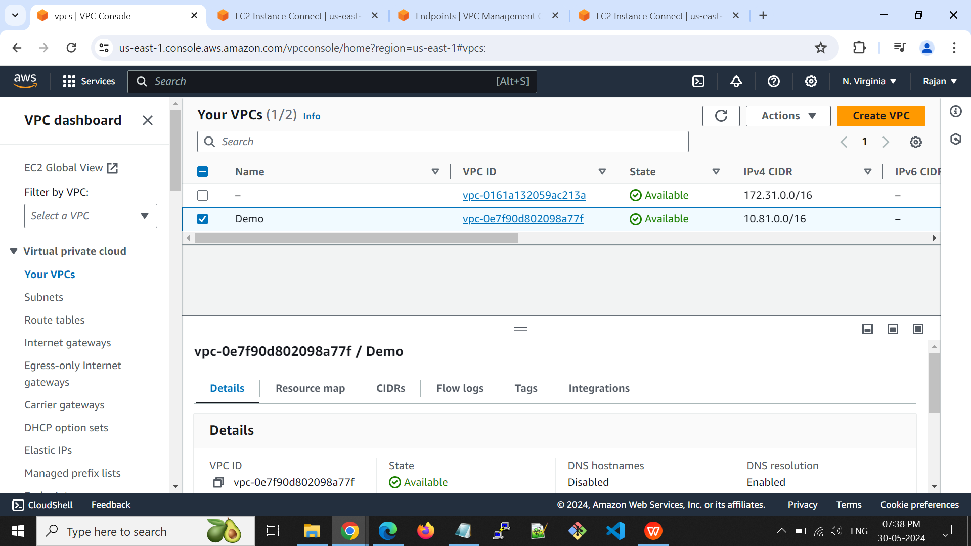

**Step 2:** Create Subnets

Created a Public and Private Subnet with CIDR range 10.81.0.0/24 and 10.81.1.0/24

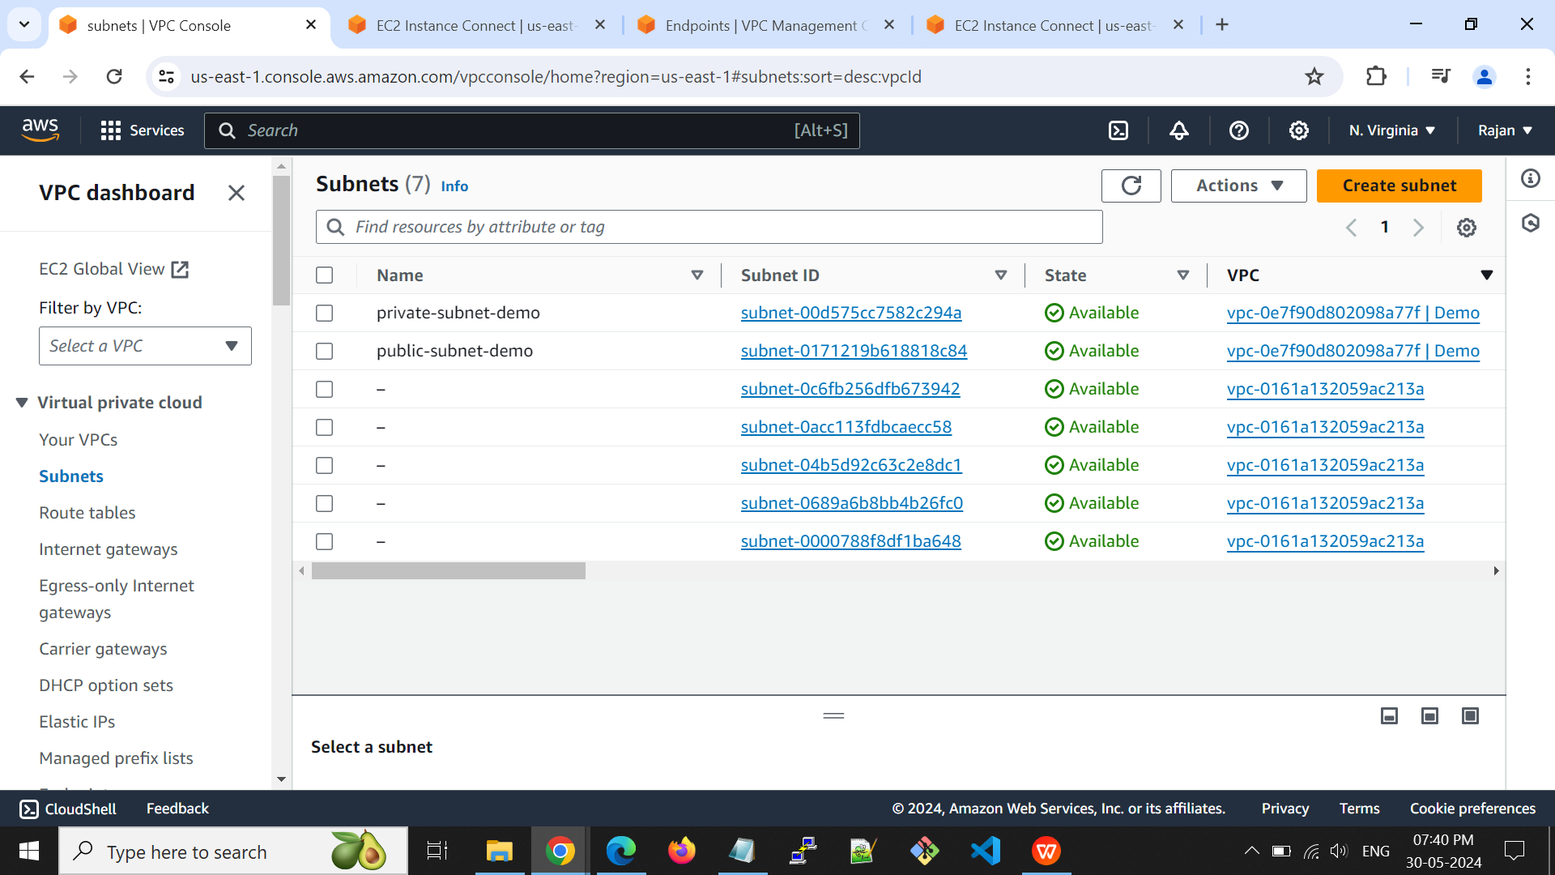

**Step 3:** Create an Internet Gateway

Created the Internet Gateway for my VPC.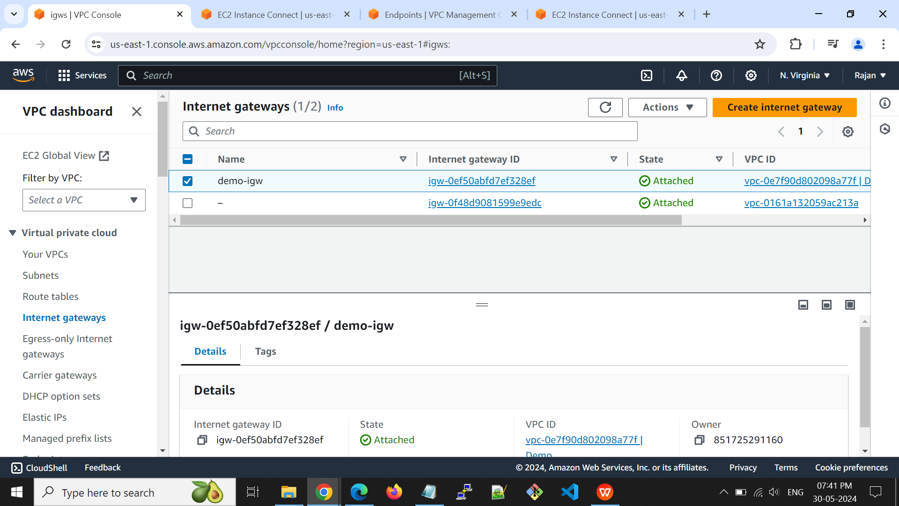

**Step 4**: Create a Route Table for the Private Subnet

Created the Route Table for private subnet and route modified.

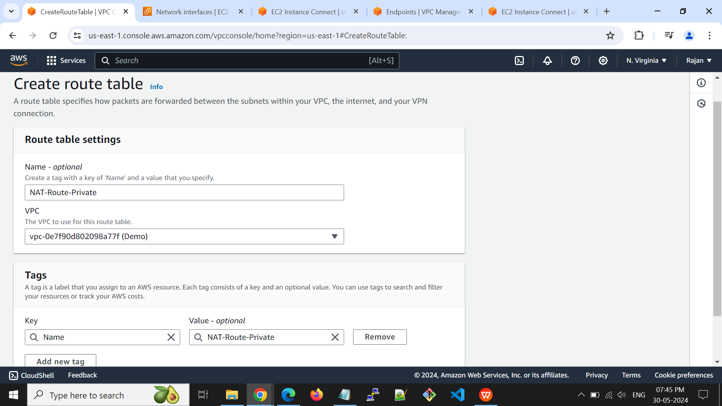

Add the destination 0.0.0.0/0 and select the created internet gateway using edit routes.

Private subnet added into the route table using subnet association option.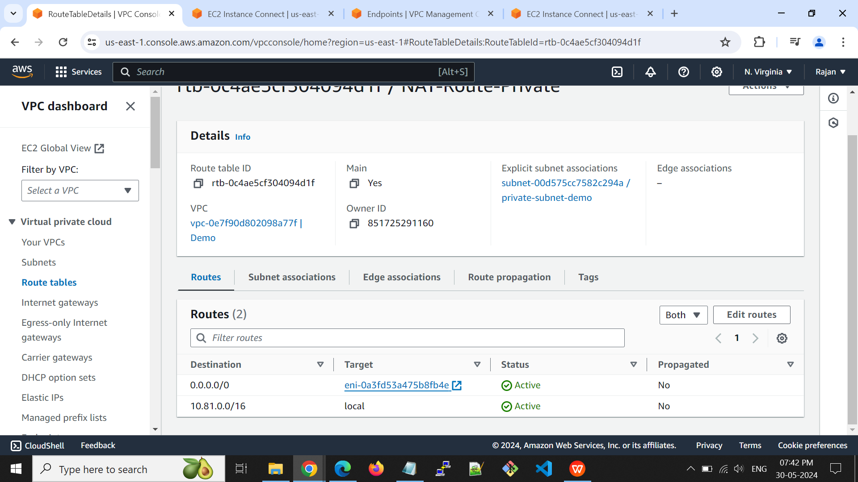

**Step 5:** Launch a NAT Instance in the Public Subnet

EC2 Instance launched on the public subnet.

Disabled the source/destination check:

Actions -> "Networking" -> "Change Source/Dest. Check."

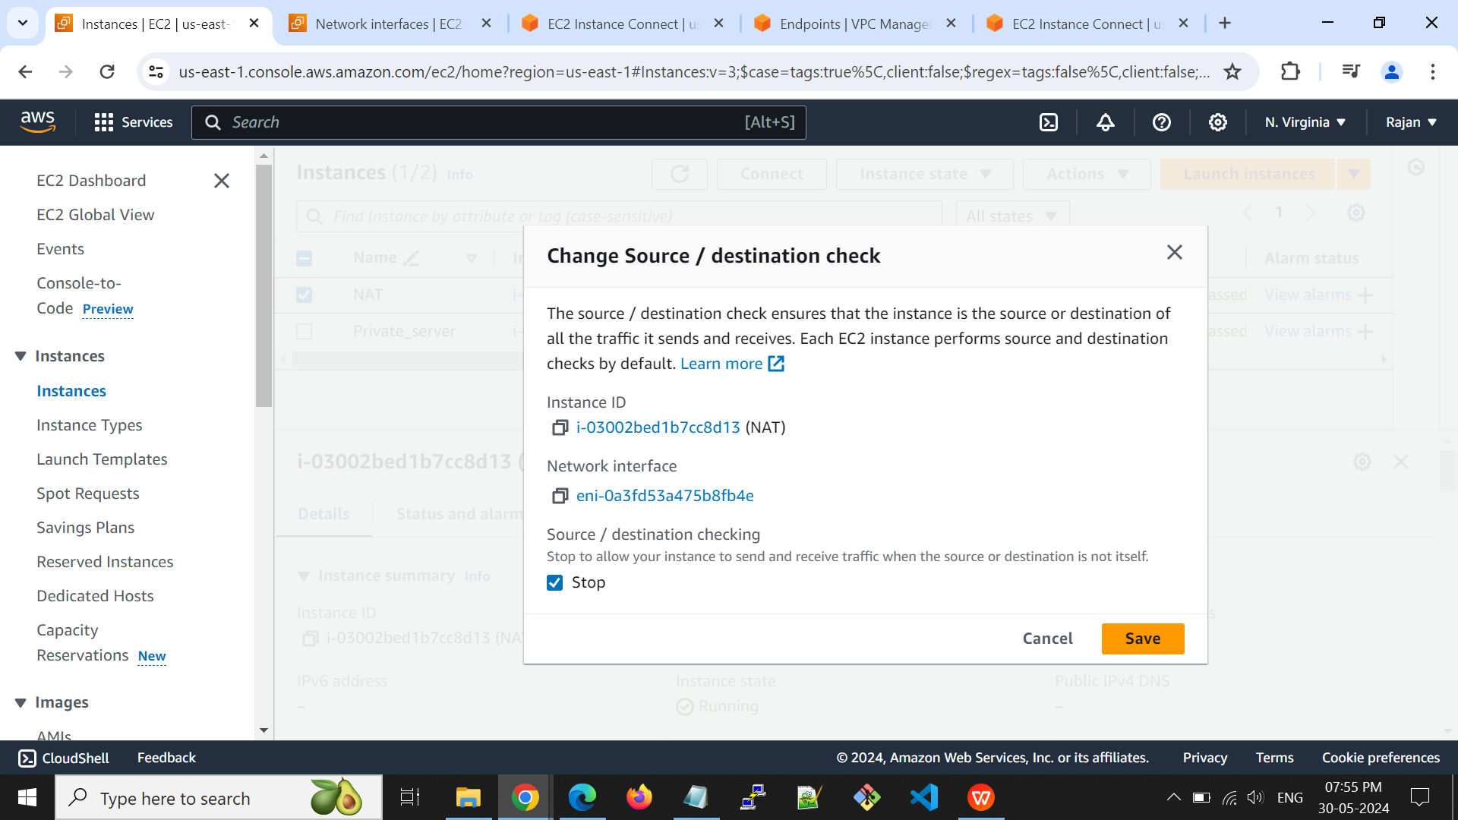

**Step 6:** Create a Route Table for the Private Subnet

Created the Route Table for private subnet

Destination added 0.0.0.0/0 and added the ID of the NAT instance created earlier.

Associate Route Table: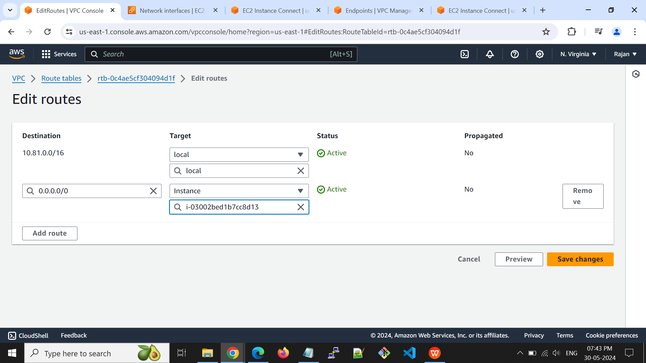

Private subnet added into the NAT route table using subnet association.

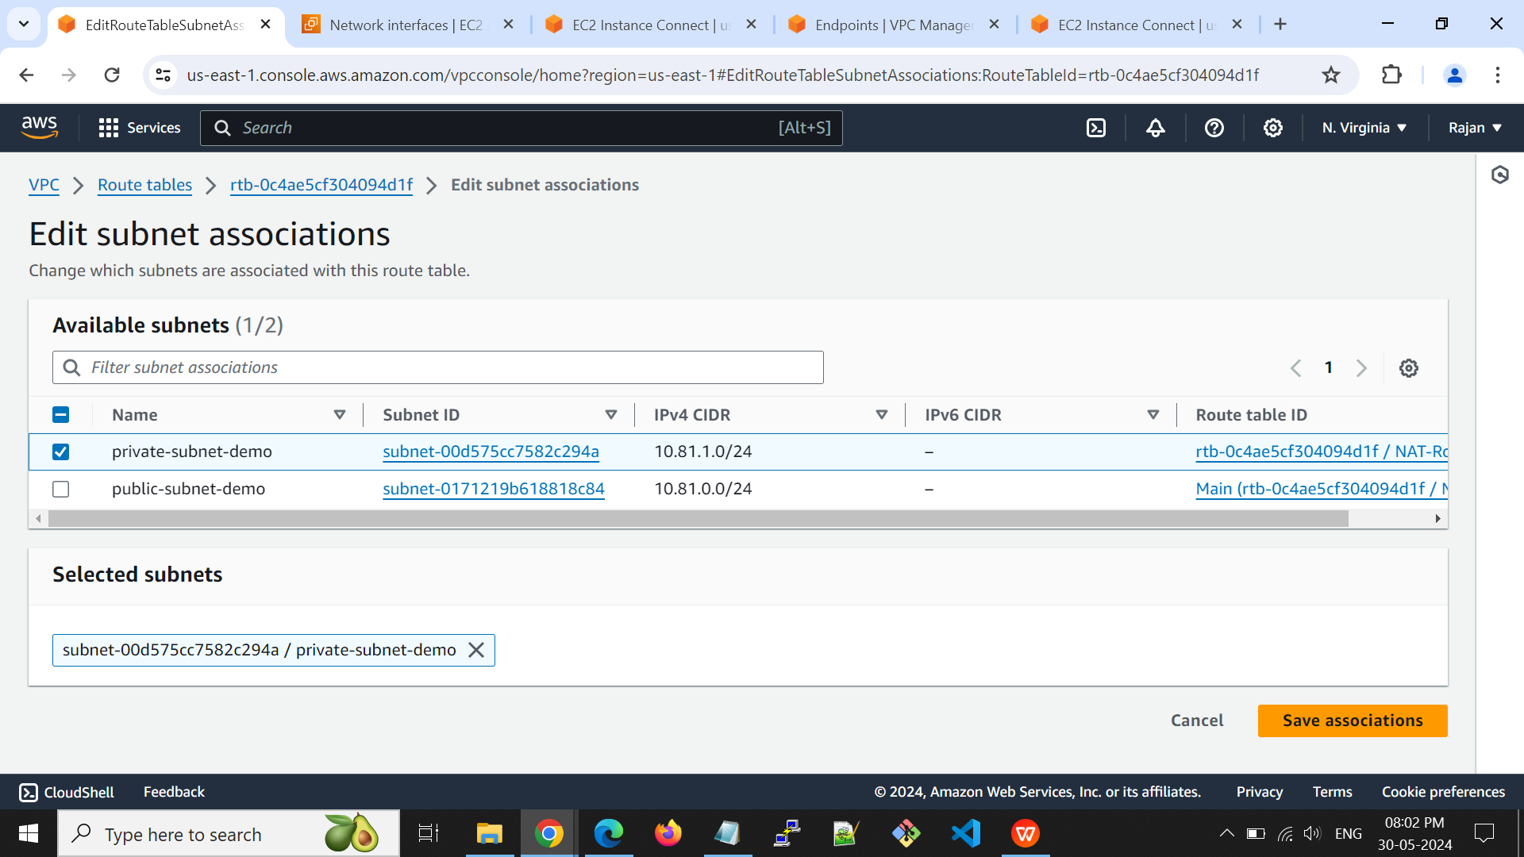

**Step 7:** Launch a Private EC2 Instance

EC2 Instance launched on the private subnet.

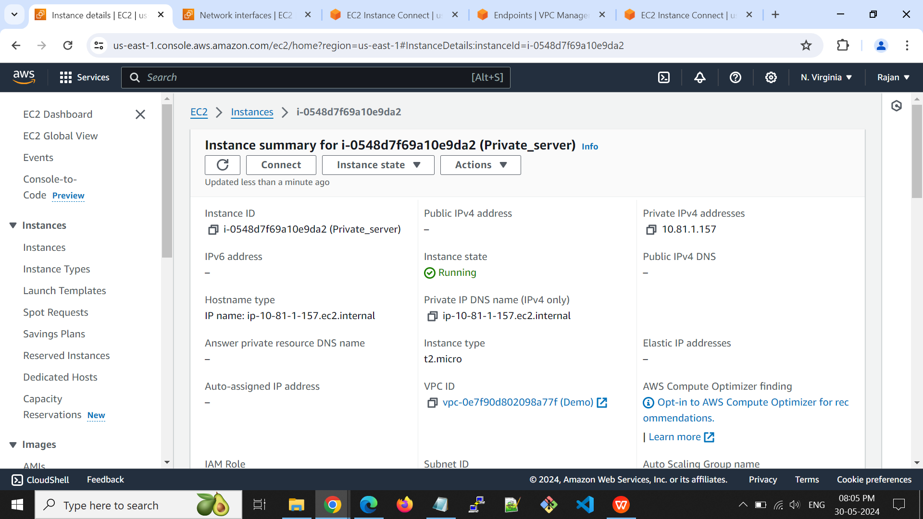

**Step 8:** Verify Internet Access

From the private instance, try pinging an external IP.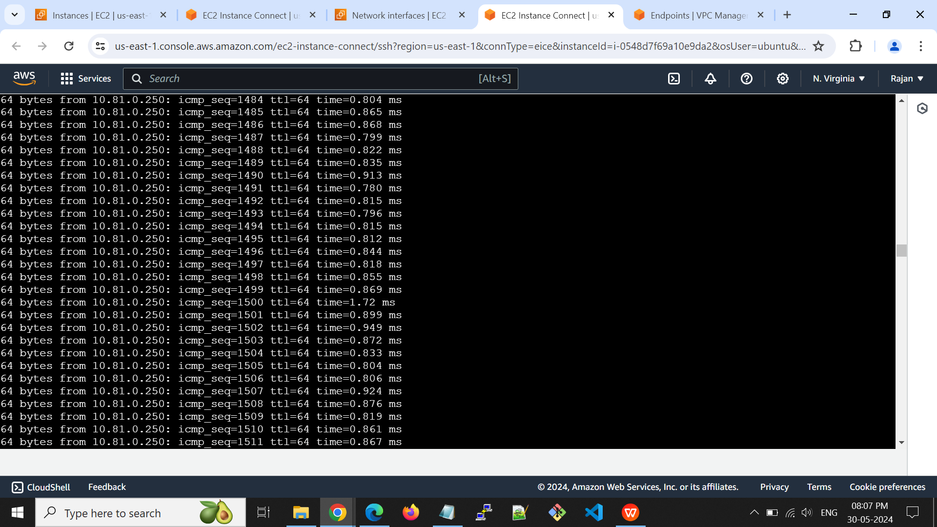

**Linux Task Day 4:-**

**Add static IP to the server in Ubuntu and Centos server.**

There are two ways to add the static IP to the server.

**Method 1:** Using ip addr add command

**sudo ip addr add <static IP address> dev <Interface>**

* The 'add' and 'dev' options are used to add an IP address to an interface.
* We have to specify the IP address and interface to be added.

**ip addr show dev <Interface>**

* Verify the Ip address added or not using the above command.
* Once Ip is added to the interface then run this command to bring the interface up.

**sudo ip link set <Interface> up**

**Method 2:** Update the configuration file.

**Ubuntu:-**

* Go to the /etc/netplan and edit the 50-cloud-init.yaml file.

sudo nano /etc/netplan/01-netcfg.yaml

network:

version: 2

renderer: networkd

ethernets:

eth0:

addresses:

- 10.81.1.142/24

nameservers:

addresses:

- 8.8.8.8

- 8.8.4.4

routes:

- to: default

via: 10.81.1.1

* Configuration updated. Now run this command to apply the changes.

**sudo netplan apply**

**CentOS:-**

* Go to /etc/sysconfig and edit the network-scripts file.

**sudo nano /etc/sysconfig/network-scripts**

HWADDR=00:08:A2:0A:BA:B8

TYPE=Ethernet

BOOTPROTO=none

IPADDR=10.81.1.141

PREFIX=24

GATEWAY=10.81.1.1

DNS1=8.8.8.8

DNS2=8.8.4.4

DEFROUTE=yes

IPV4_FAILURE_FATAL=no

IPV6INIT=no

NAME=eth0

UUID=41171a6f-bce1-44de-8a6e-cf5e782f8bd6

DEVICE=eth0

ONBOOT=yes

* Configuration updated. Now run this command to apply the changes.

**sudo systemctl restart network.service**